**A Very Basic Guide to Remapping Controllers for Ostim and Wheeler Functionality**

**Part 2 Steam Setup**

If you have not completed Part 1 go do so now.

1. Now we are going to have to make The OCM list run inside of Steam so the Steam overlay will work.
2. Open MO2 if not already open.
3. Under the run key you should see shortcut, press it.
4. Select desktop, this should of just made a shortcut on your desktop. Put that shortcut wherever you like but keep track of where it is. It probably says SKSE because this shortcut will open MO2 and then autorun SKSE. You can rename it whatever you want, or leave it.

1. Next we will need to open up Steam Library.
2. In the bottom left corner you should see “Add a Game” Press it and select “Add a non-steam game”
3. Now hit “browse” and go to your desktop and click on the shortcut you made and hit open.
4. Now click “Add Selected Programs”
5. You should now see ModOrganizer or SKSE in your list like below.

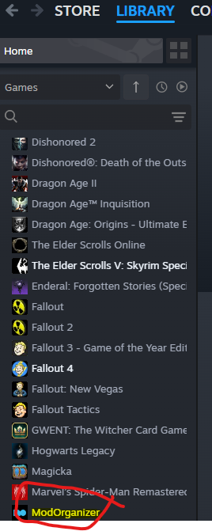

1. Click on it then click the gear icon on the far-right hand side and go to properties.
2. Now find your shortcut that you made in MO2 which should be on your desktop and right click it and go to properties. If you look at the two targets they are mostly the same but your steam one is probably missing the "moshortcut://:SKSE" we need to add that so steam launches SKSE immediately after opening MO2. Copy the target from the shortcut and paste it into the steam target.

Before

After Copy and paste. This is how it should look.

You can also rename the Steam Shortcut if you want so it will show up in Steam the way you want. You do that in the top box where it says ModOrganizer currently. I named mine Skyrim – OCM incase I have other lists.

1. Now click “controller” which is under shortcut in the Steam box.
2. Where it says override for ModOrganizer (Note-if you named your game something different in steam it will say that name instead of ModOrganizer) select “Enable Steam Input”

1. Close that box. One more thing to do in Steam before we launch the game.
2. In Steam settings go to In Game and click on “Enable the Steam Overlay while In-Game” This will allow you to hit Shift and tab to open the overlay in game.

1. Now close that box. You should now be able to launch the OCM Playlist right in the Steam launcher. You can also use their Big Picture to launch it, I have no idea what that is for but some do I assume.
2. Launch the game from steam and it should open MO2and launch the game itself on it’s own. If it is not doing this then check your shortcut.

Part 3 will go through how to setup the controller in game.